

Year 9 Science
Biology 1 Test: Systems

SECTION 1: MULTIPLE CHOICE (1 mark each)
Circle your answer on the multiple choice answer sheet.

- Digestion starts in the mouth using digestive enzymes in ________.
  - Bile
  - Saliva
  - Proteins
  - Glucose

- Duodenum is the first 30cm of the ___________.
  - Liver
  - Large intestine
  - Small intestine
  - Oesophagus

- Stomach acid, contains a certain amount of what acid?
- Hydrochloric acid
- Nitric acid
- Carbonic acid
- Ammonia acid

- Calcium, Iron, Sodium and Copper are all types of?
- Enzymes
- Vitamins
- Fibre
- Minerals

- B1, B2, B3, A, C, D, E and K are all types of?
- minerals
- vitamins
- enzymes
- fibre

- Proteins are made of?
- Fats
- Carbohydrates
- Sugars
- Amino acids

- Carbohydrates supply what for the body?
- Vitamins
- Fibre
- Minerals
- Energy

- What part of the digestive system removes waste materials
  - Large intestine
  - Small intestine
  - Rectum
  - Both a and c

- What two body parts in the digestive system can we still function without them
  - Large intestine, small intestine
  - Duodenum, pancreas
  - Gallbladder, appendix
  - Liver, caecum

10. The part of the body that filters blood and produces Urine is the
- Bladder.
- Kidney.
- Heart.
- Lung.
11. _________ is the removal of unwanted substances made by your cells
- Excretion
- Metabolism
- Kidneys
- Cortex

12. From the bladder there is a tube called the ___________
  - Ureter
  - Urine
  - Urethra
  - None of the above

13. The main organs of excretion are the ____________
  - Anus
  - Rectum
  - Liver
  - Kidneys

14. Bile is made in the liver what colour is it ___________________
  - Redish-yellow
  - Orangeish-yellow
  - Greenish-yellow
  - Brownish-yellow

15. A healthy large intestine contains a large amounts of___________
  - Materials
  - Water
  - Food
  - Bacteria

SECTION 2: WRITTEN
Write your answers in the spaces on the answer sheet provided.

- Name the parts of the digestive system labelled on the diagram below (12):

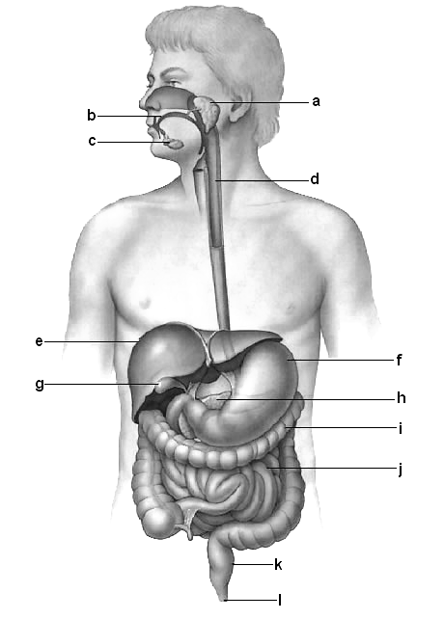
2. Describe the function of f, h and i. (3)

3. Fill in the food pyramid below with the correct labels of foods (5).

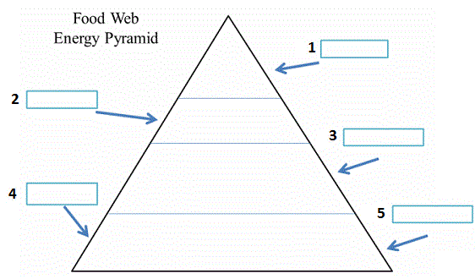

- Bread
- Mars Bar
- Cheese
- Steak
- Apple

END OF TEST (OUT OF 35 MARKS)

